**How to manually update the Practice Management SQL Instance (PRACTICEMGT) from SQL 2014 – 32bit to SQL 2019 - 64bit.**

**Prerequisites before getting started:**

1. Your server must be running the 64bit version of Windows.
2. Plan on at least 2 hours of downtime.
3. You must reboot the server in between uninstalling and reinstalling SQL.
4. Everyone must have all Practice Management modules closed. This includes the PM Tray that may be running.
5. The entire process must be done sitting at the server, or via remote desktop to the server.
6. You should create a backup of all Practice Management databases before starting.
   1. Master, Model, MSDB, and TempDB databases do not need backed up. They do not include any Practice Management data.
   2. Any databases that start with PracticeVerify_ do not need backed up. These were created temporarily during the last Practice Management version upgrade.

**Step 1: Remove the SQL 2014 - 32bit (PRACTICEMGT) Instance.**

1. Open Programs and Features
2. Locate and select **Microsoft SQL Server 2014 Setup** and click **Uninstall**
3. When the SQL Server 2014 box comes up, click **Remove**
4. On the Select Instance window, select **PRACTICEMGT** in the drop-down menu if not defaulted
5. Click **Next**
6. On the **Select Features** window, check the **Database Engine Services** option only
7. Click **Next**
8. On the **Ready to Remove** window, click **Remove**
9. Once completed, click the **Close** button

**Step 2**: **Reboot the server**

**Step 3: Download SQL Server 2019 Express for Practice Management (PRACTICEMGT)**

1. Click here to visit the SQL Server 2019 Express download page: [SQL Server 2019 Express Download Page](https://www.microsoft.com/en-us/Download/details.aspx?id=101064)

or browse to https://www.microsoft.com/en-us/Download/details.aspx?id=101064

1. Click the red **Download** button to start downloading the **SQL2019-SSEI-Expr.exe** file

**Step 4: Manually installing SQL Server 2019 for Practice Management (PRACTICEMGT)**

1. Right click SQL2019-SSEI-Expr.exe and choose to install
2. On the **Select an Installation Type** screen select **Custom**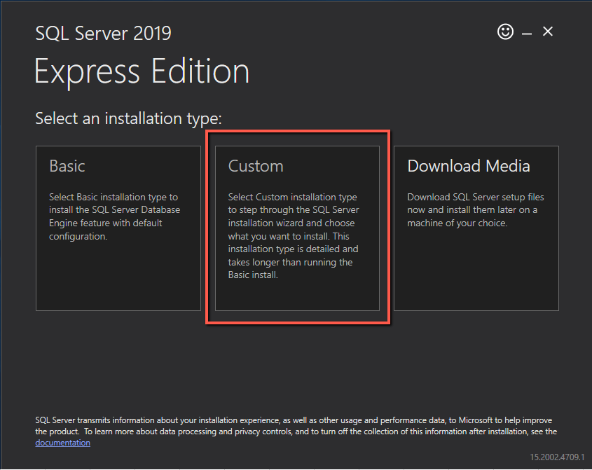
3. Click **Browse** to select a storage location that has plenty of free space if the default of

“C:\SQL2019” does not have enough room.

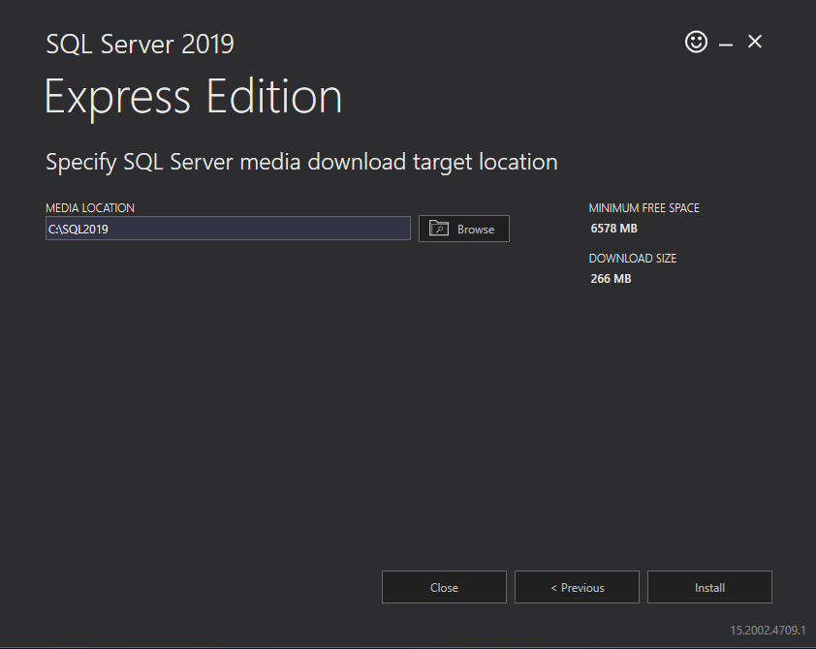

1. Click the first line **New SQL Server Stand-Alone Installation or Add Features to an Existing Installation**

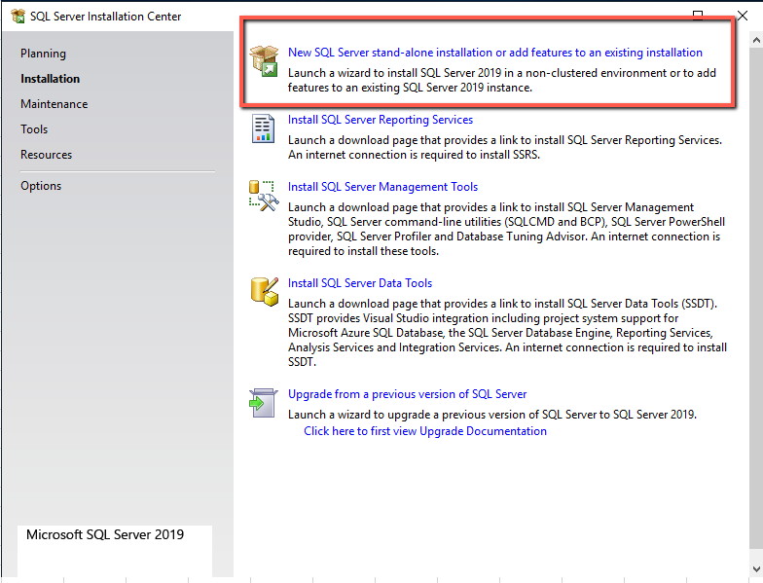

1. The **Global Rules** will be checked then the **Microsoft Update** screen will display. Enable Microsoft Update to check for updates if desired and click **Next**
2. **Setup Rules will be checked**
   1. If you have any failures, you will need to fix the issue and restart the process to be able to continue
   2. Warnings do not need to be corrected for the install to continue but should be heeded
3. **Check the Box** to accept the License terms and click **Next**.
4. If you have an existing SQL Server 2019 instance, you will need to select to **Perform a new installation of SQL Server 2019.** Click **Next**

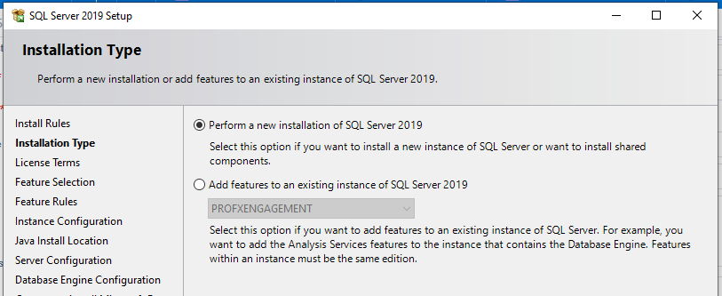

1. On the **Feature Selection** screen use settings below for minimal install for the **PRACTICEMGT** instance

Instance Root directory should stay on C drive per Microsoft’s recommendations for services

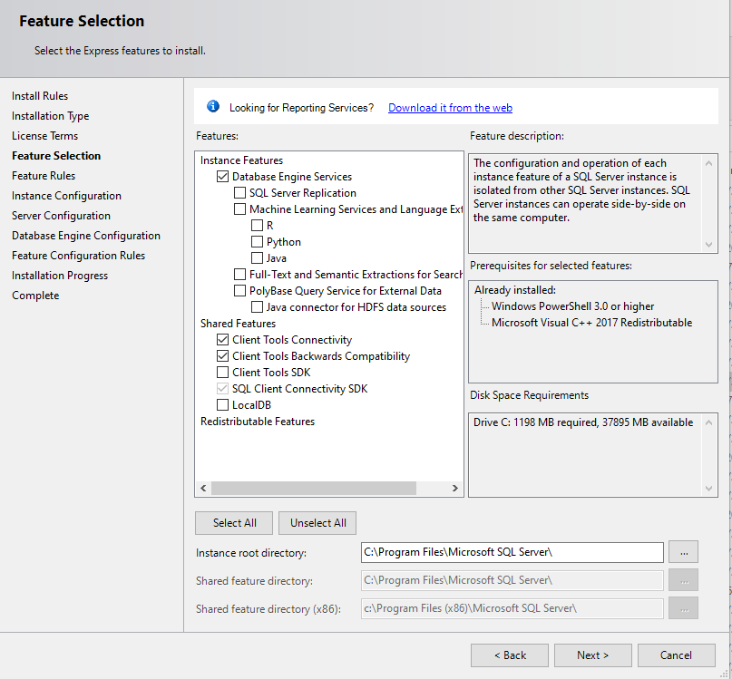

1. Click **Next**
2. On the **Instance Configuration** screen, type in the **Named Instance**: **PRACTICEMGT** and hit the Tab button

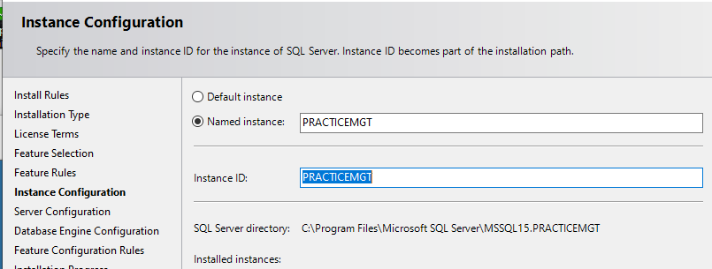

1. Click **Next**
2. On the **Server Configuration** screen:
   1. Make sure to change **SQL Server Database Engine** to **NT AUTHORITY\LOCAL SERVICE**
   2. Make sure **Startup Type** is **Automatic** for Both lines.
   3. **Check the box** to **Grant Perform Volume Maintenance Task**

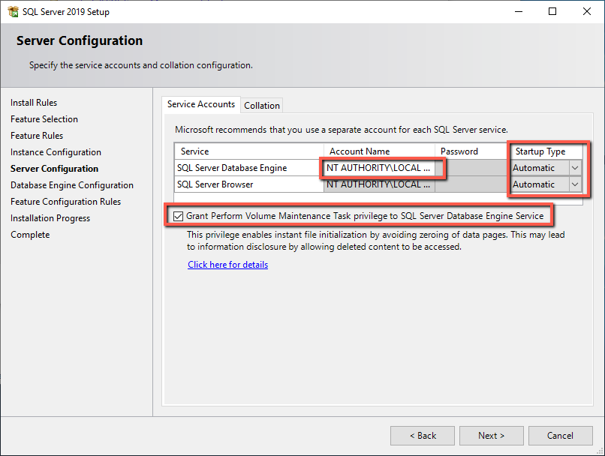

1. Click **Next**
2. On the **Database Engine Configuration** page:
   1. **Authentication Mode** must be **Mixed Mode**
   2. **SQL Server SA account password** should be: **PracticeUser1**
   3. **SQL Server Administrator** should add the Domain Administrators or Local Administrators group. Doing so will provide assistance with Windows Logon to the SQL Instance if the SA password is lost

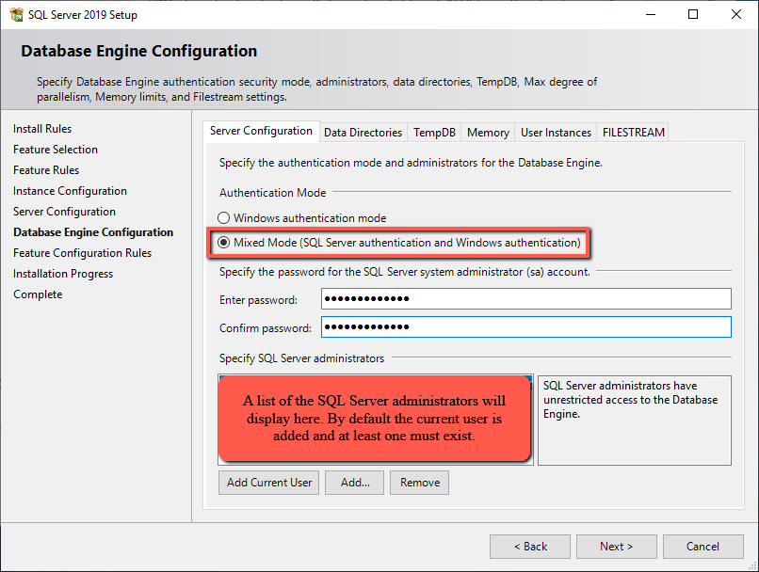

1. Click **Next.** The Install will now start
2. The install should now be **Complete** without errors

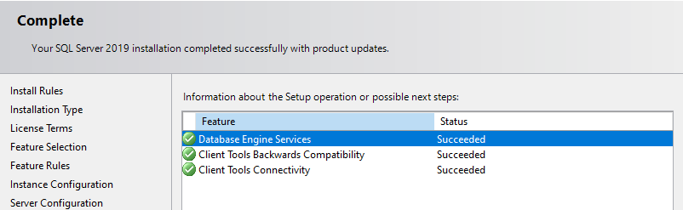

1. Click **Close**
2. **Close** the **SQL Installation** **Center by clicking the X** in the top Right of the window

**Step 5. Enable TCP and Named Pipes for the PRACTICEMGT SQL Instance**

1. In Windows, using the Start Menu, locate the **Microsoft SQL Server 2019** folder
2. Launch the **SQL Server Configuration Manager**
3. **Expand** the **SQL Server Network Configuration** section
4. Highlight the **Protocols for PRACTICEMGT**

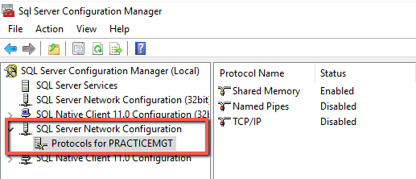

1. Right click **Named Pipes** and select **Enable**

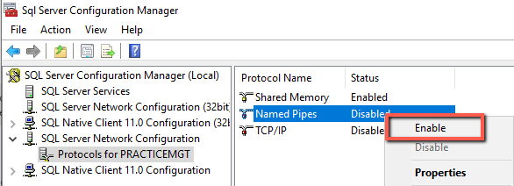

1. Click **OK**. A Warning message will come up that Services need restarted before taking effect. Click **OK**
2. Right click **TCP/IP** and select **Enable**

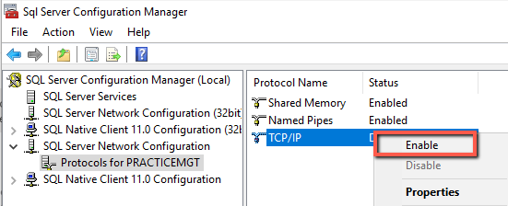

1. Click **OK**. A Warning message will come up that Services need restarted before taking effect. Click **OK**
2. Go to the **SQL Server Services section**. Highlight **SQL Server (PRACTICEMGT)**
3. Click the **Restart** button (**circle with arrow)** which will restart the service

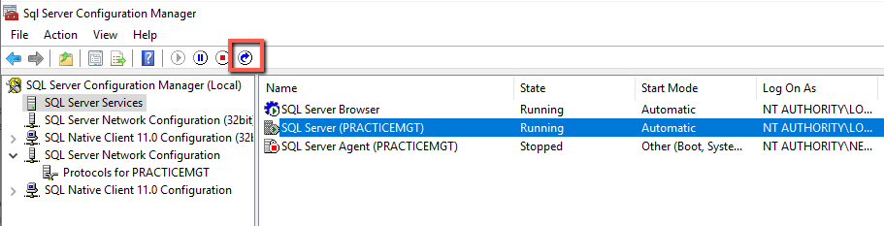

1. Once the Service has restarted, close SQL Server Configuration Manager.

**Step 6: Re-Attaching the Practice Management databases.**

1. Copy the data files from the old location to the new location.
   1. The database files should be located in:

C:\Program Files (x86)\Microsoft SQL Server\MSSQL12.PRACTICEMGT\MSSQL\DATA\

There will be 2 files for each database you move (one with a MDF file extension and another with a LDF file extension.

* 1. Place these data files into your new install location’s Backup folder. By default this will be:

C:\Program Files\Microsoft SQL Server\MSSQL15.PRACTICEMGT\MSSQL\Backup\

1. Browse to run C:\Program Files (x86)\Practice Management\cpas\vpm\cpasSQLUtil.exe
2. On the Server line, make sure you select the **‘server name’\PRACTICEMGT**
3. Authentication needs to be changed to **SQL Server Authentication**
4. User Name: **SA** andPassword: **PracticeUser1**  Then click the **Logon** button.
5. Right click on the top line that has the name **‘server name’\PRACTICEMGT** and select **Attach Database**
6. Browse to the Backup folder as stated in step 1-b
7. Select the database file. You can only attach 1 database at a time if you copied multiple. Click **Open**.
8. You will receive a message that it will copy the database to the Data folder. Click **OK** to continue.

Once it has been copied, the screen will refresh and list it with the rest of the databases.

1. Click **File > Accounts > Assign User Account**
2. Enter your database name in the Account field
3. Enter a password that meets your minimum Domain password requirements. Example is: Today12345

If you need to make it longer, add more numbers. If Special Characters are required, you will need to Install Microsoft SQL Management Studio and call Practice Management Technical Support to assist further

1. Select your database name from the **Database** drop down list
2. Click **Save**.
   1. If you have more than 1 database you are re-attaching, repeat steps 6-14
   2. If you only attached 1 database, you can close the CPAS SQL Utility

**If you had to enter firewall exceptions previously, then you will need to edit / add new ones for the new Service.**

[**Click Here For Help With Firewall Exceptions**](https://support.cch.com/kb/solution/000036200/sw42566)