Enrollment – Main Offices

First, ERO’s must complete the Office Info section. The information we have on file will flow from our customer database program into Central Office Manager (COM) the ERO only has to complete the missing information and submit at the bottom of the screen. The main office must use this screen. Any suboffices can be set up through a spreadsheet import that has the same fields.

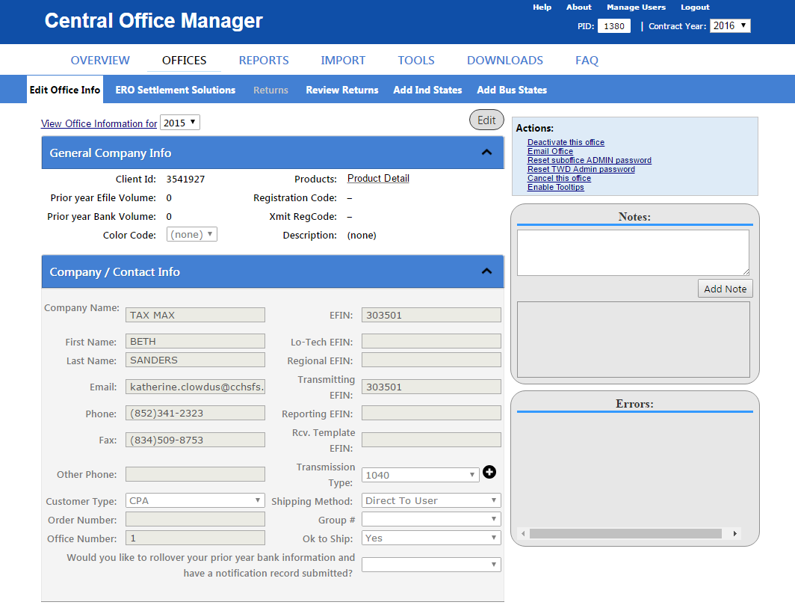

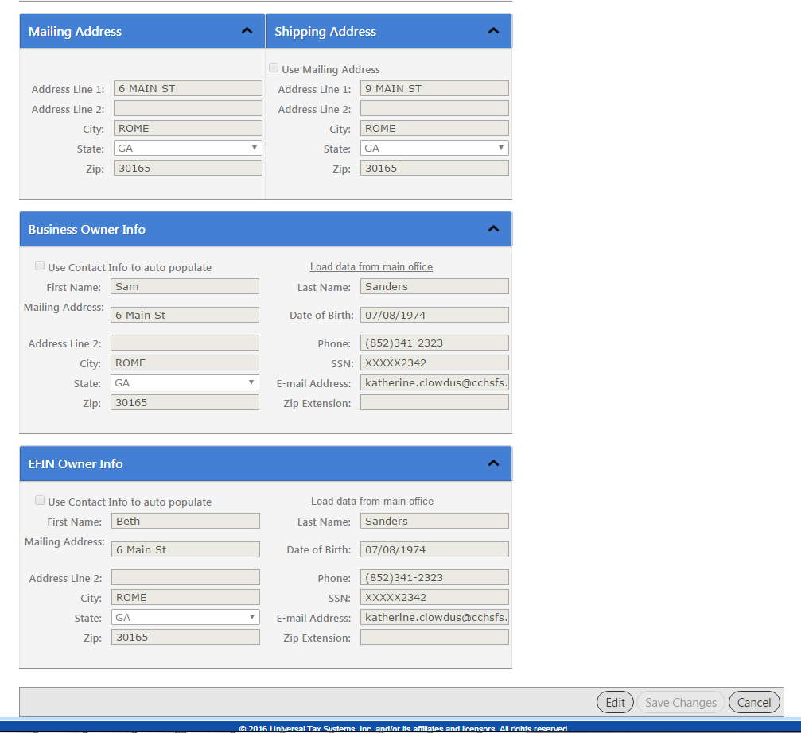

Once the office information is entered and the office has changed to active, the ERO will go to ERO Settlement Solutions to select their bank. The company info will display at the top of the page. The ERO will click on the drop down arrow next to the provider they are selecting.

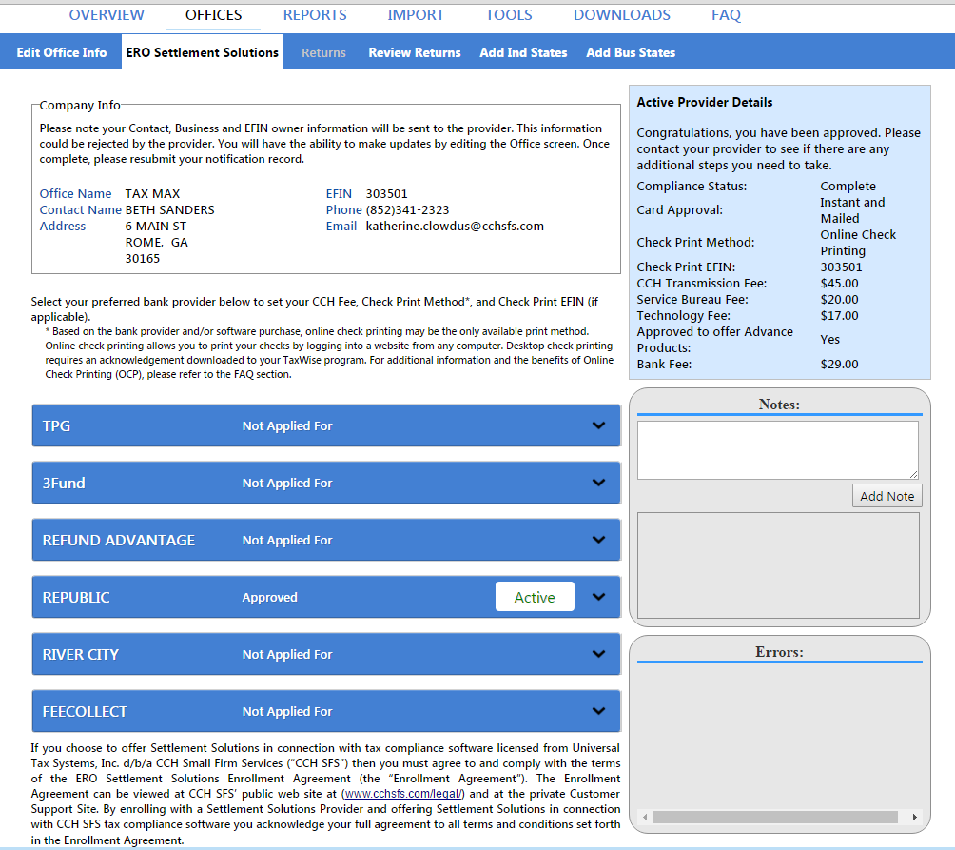

The drop down arrow will display the information for the provider and the editable fields. The ERO will click on Edit, enter the check print efin, check print method (online or desktop), CCH transmission fee, and service bureau fee if applicable. Once the information is entered, the ERO will click submit to send the enrollment record to the provider. If the ERO has applied for the provider in error, or wishes to change banks, the deactivate button will change the application to a deactivated status.

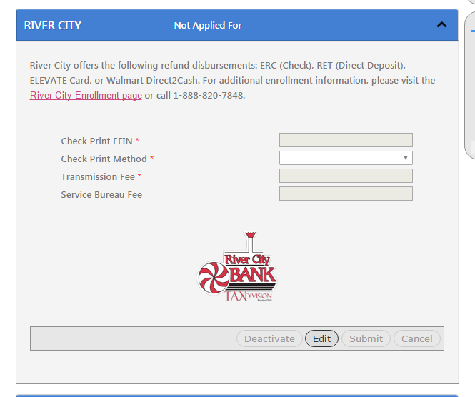

The alternative way for the main office to set up the suboffices is through a spreadsheet import. The import tab has two choices, offices import (sets up office information as an alternative to completing the edit office info screen for each suboffice) and ero settlement solution. The ERO would either export a spreadsheet with the main office provider information or fill out the information on a blank template and then click the Import ERO Notification Record link. This would import the data into COM and create enrollment records for the suboffices. The Import ERO Notification Record is specific to provider.

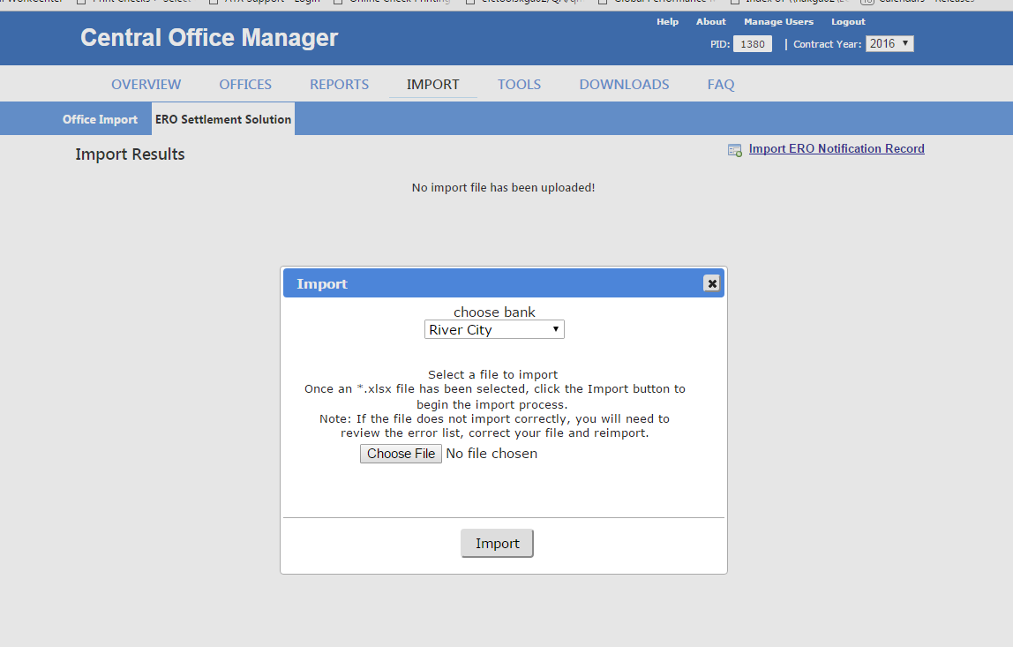

Screenshot of the enrollment spreadsheet for River City.

