Why is the Schedule K-3 part II Section 1 not pulling the information for all the countries?

When there are multiple countries input for the Schedule K-2/K-3 each line on the form is assigned to a country in alphabetical order. This can result in multiple pages of the Schedule producing and some lines appearing blank.

Example:

US should show on Schedule K-3 part II Section 1 line 1

Input - 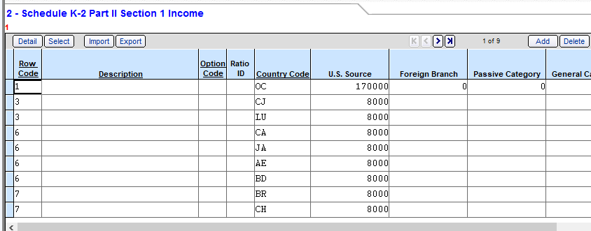

Output - 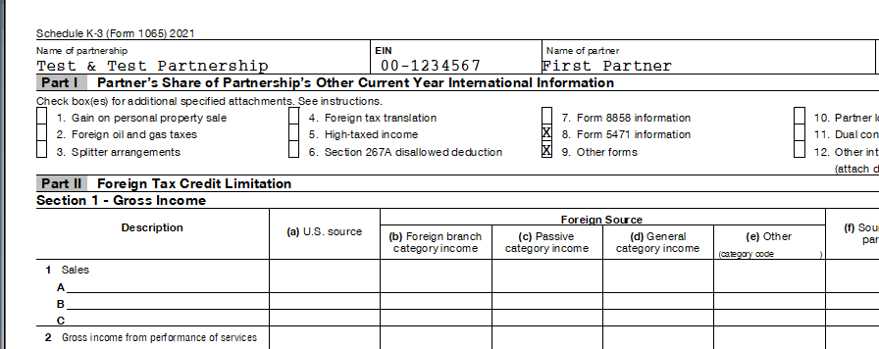

In this example sheet 1 line A is assigned to country code AE, line B is assigned to BD and line C is assigned to BR. US will appear on another sheet of the Schedule K-3

