This document is intended for Wolters Kluwer customers licensed to use CCH Axcess™ Portal. This document is a template ready for you to customize and distribute to your clients. Instructions for customizing this document are outlined below.

- To begin, search for “[firm name]” and replace with your actual business name, “us”, “the firm” etc.
- Customize the cover page and text within the guide as appropriate to meet your firm policies.
- After the word file is customized, convert to a PDF file for distribution to clients.
- Ensure this instructions page is not included in the final client deliverable.

This document is composed of multiple parts including sections composed of basic features and an advanced section for clients with more complex portal requirements. Portions of this document may be delivered to clients based on their needs. Individual tax clients may not need the advanced section, whereas business clients with more complex needs will benefit from the entire document.

CCH Client Axcess™ Portal User Guide

[Firm Name]

Icon Legend |  | Tips | Best practice tips and shortcuts
 | 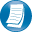 | Notes | Informational notes about functions
 |  | Warning | Important warnings about a function

Logging in to CCH Client Axcess
Refer to your welcome email for the temporary password needed for your initial login to Client Axcess.

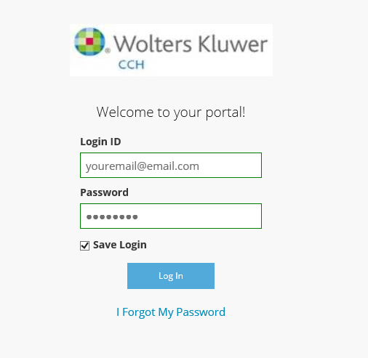
Login

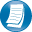
Login Tips
- The Login ID (email address) is not case sensitive; the temporary password is.
- You will be required to change your password upon logging in for the first time and answer security questions. Your security questions can help you access your portal if you ever forget your password.
- Your new password may be from 8 to 32 characters in length, must contain at least one alpha character, one numeric character, and one special character (e.g. !, @, #, etc.). The password is case sensitive.
- Your password may be reset at any time by clicking “Forgot password?”.
- If prompted, review and agree to the [firm name] end user license agreement. You can also download a copy.

Downloading files from Client Axcess
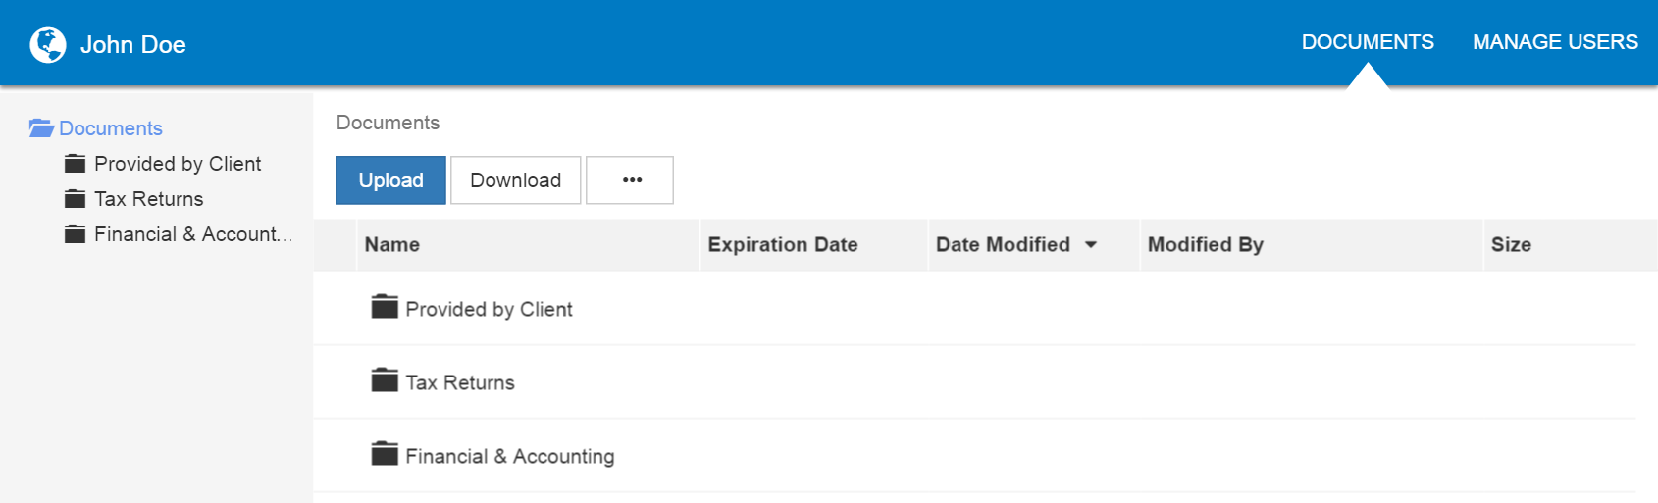
Client Axcess Home Page

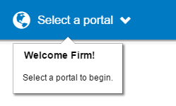
If you have access to more than one Portal, click Select a Portal at the top, left-hand portion of the page.
Select a portal

After logging in to Client Axcess, you will see a list of folders used to organize your files. Click on a folder to display its files.

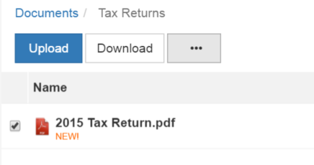
Download Files

To download a file, simply click the file name or check the box and click Download, either option will launch your browser’s file download prompt allowing you to open or save the file.

To download files, it may be necessary to disable your pop up blocker in Google® Chrome®, or other web-browsers.

Uploading files to Client Axcess
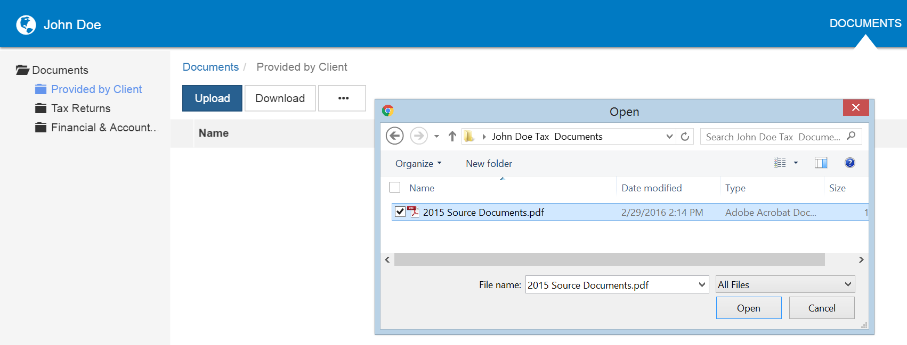
1
3
2
Upload Files
Follow the steps to add a file to you Client Axcess portal:

- Click the destination folder (where the file will be located)
- Click Upload, browse to and select the file(s) you wish to upload
- Click Open

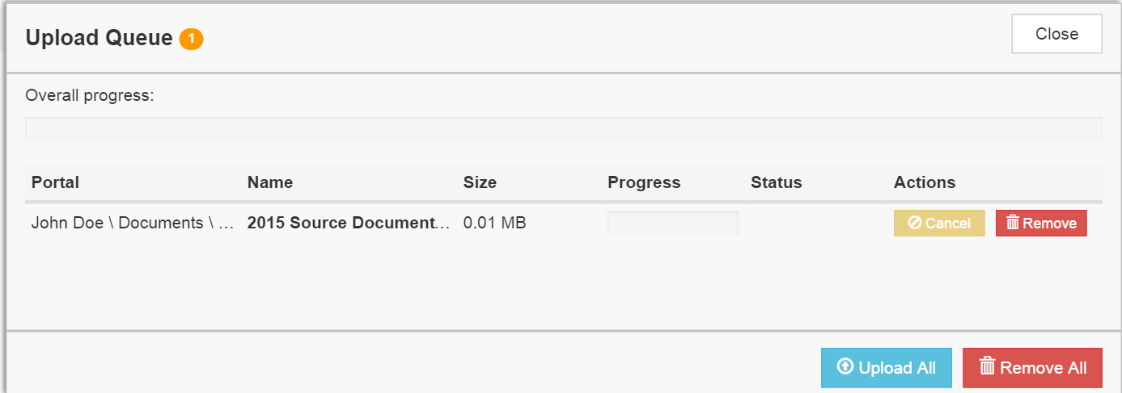
4
Upload Queue

- The Upload Queue will launch automatically. Click Upload All to upload the displayed file(s) to Client Axcess.

You will see an on-screen confirmation that your file(s) were successfully added to Client Axcess. Return to your Documents or simply close your browser window to exit Client Axcess.

You can also drag-and-drop files into the destination folder to activate the Upload Queue. Once the Queue is displayed, click Upload All and your files will be added to Client Axcess.

Click the 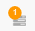 icon at the top, right-hand corner of the page to reactivate the Upload Queue if you accidentally minimize it prior to selecting Upload All.

Working with Files in Client Axcess

Deleting Files
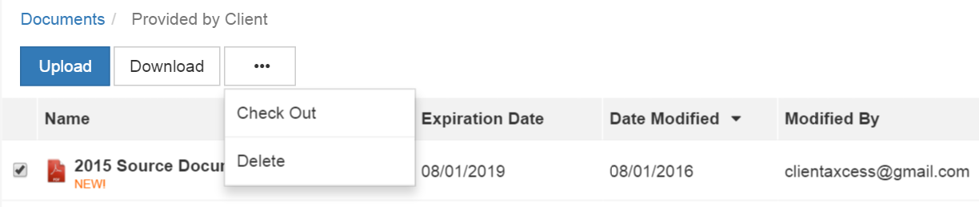
Delete Files

You can not delete files uploaded by [firm name] or other Portal users. You can delete files that you upload. Click the box to the left of the file name, click the More Options (ellipsis) button, and then choose Delete. You will be prompted for confirmation, click Yes to remove the file from Client Axcess.

If you would like to have a file added by [firm name] or another portal user removed from Client Axcess, follow the steps above, but choose the option “Request for Deletion”, which will be displayed instead of the Delete, and will email to [firm name] notifying us that you want the file to be deleted.

Checking Out Files
Collaborate with [firm name] by using the Check Out feature to download a file, make changes, and then add the modified file back to Client Axcess. The file will be overwritten to reflect your changes upon Check In.

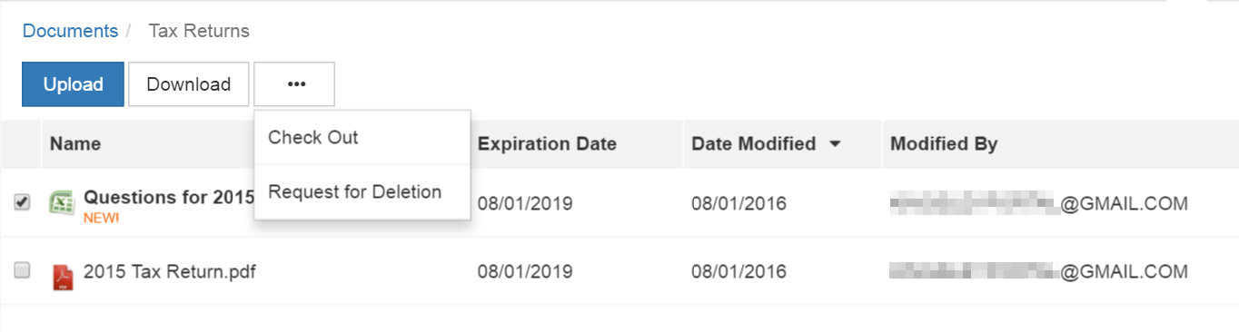
Check out a file

Steps to Check Out a file
- Check the box to the left of the file name, and then click the More Options (ellipsis) button
- Select Check Out
- On the Check-out prompt, click the Due date to check in field, and choose the latest date you expect to Check In the file, then click Check Out
- When prompted by your web browser, save the file to your computer or network
- Launch the file and make any desired changes, then click Save and close

Checking in Files
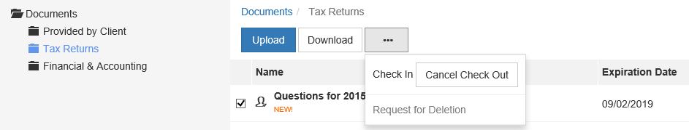
Check in a file

Steps to Check In a file
- Log in to Client Axcess, browse to the folder where the checked out file is located
- Check the box to the left of the file name
- Click the More Options (ellipsis) button, and select Check In
- When prompted, click Browse and navigate to the checked out file on your computer.
- Click Check In
- You will receive confirmation the file has been checked in successfully

Changing Passwords and Logging Out
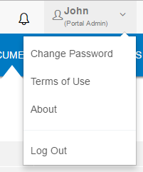
User Options

At the top right-hand portion of the page, click the arrow to view your user options. From this menu you can change your password or Log out of Client Axcess.

Advanced Features
This section is intended to provide further assistance on the more complex features available to a Portal Admin user. The advanced features are optional, and are not required for each Client Axcess portal.

Portal User Roles

Portal Admin
The Portal Admin is the primary user for each Client Axcess portal. The Portal Admin may perform all portal-related functions, create other Portal Users and control access for other Portal Users. The Portal Admin user will be the only user that exists initially when a portal is created.

Portal User
A Portal User is created and granted access by the Portal Admin or the firm. Portal Users should only be created when Portal access is required by more than one person.

Example of Advanced Portal Use
- You may find situations in which it is practical to grant portal access to a third party. For example, a banker that you and the firm collaborate with on a regular basis. Before having access to Portal; options to exchange information included email, fax, CD-ROM, or hard copy paper, and in many cases you had to request the document from the firm before you could provide it to the bank. As the Portal Admin, you may create a Portal User allowing your banker access to requested documents and the ability to add files at the request of you and the firm; considerably reducing the time and resources spent to exchange information. The security level of Portal far exceeds email, which is most often the primary medium of exchanging electronic files.

- If the firm has created more than one portal for you, you will be able to control which portal(s) your banker or other third party may view.

- Your firm’s portal solution, may or may not, provide you with the ability to secure folders. If available, this feature allows the Portal Admin to control a Portal User’s access to one or more folders within a portal.

Managing Portals
The Portal Admin may grant portal access to others by creating Portal Users.

There are three steps to create Portal Users:
- Create the Portal User
- Grant the Portal User access to one or more portals
- Choose the Portal User’s File Management Role for each portal they are granted access

About File Management Roles

There are five File Management Roles that can be assigned:
- Administrator – Allows Portal Users to perform all file operations.
- Standard User – Allows Portal Users to perform the most common file operations.
- Limited User – Allows Portal Users to perform a limited number of file operations.
- Read-only User – Allows Portal Users to download files and review related information.
- Upload-only User – Allows Portal Users to upload files and review related information.

It is our recommendation that Administration rights NOT be granted to Portal Users.

Create Client Axcess Portal Users
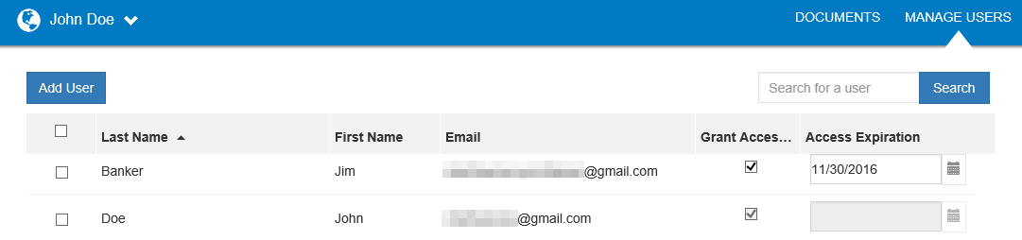
Add Portal User

From the Client Axcess home page, click Manage Users, then click Add User.

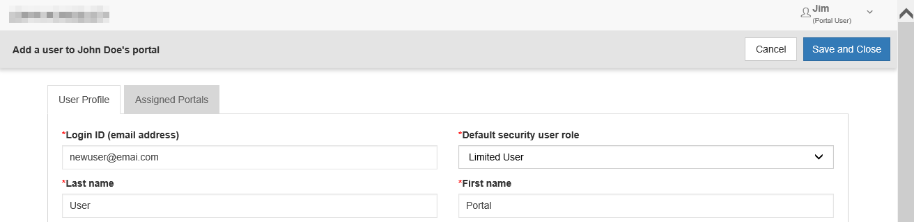
Create Portal User

On the User Profile tab, enter the Login ID (email address), last and first name of the user; these are the only items that are required. The next step is to click the Assigned Portals tab.

Create Client Axcess Portal Users Continued:
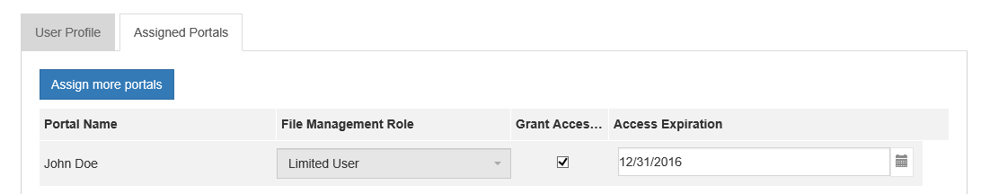
Assign Portals to a Portal User

Assign a Portal User to a Client Axcess Portal
- Initially, only the portal you are logged in to displays, check the Grant Access box to allow access to this Portal. Click Assign more portals to grant the new user access to other portals the firm has created for you, if applicable.
- If necessary, modify the assigned File Management Role for the selected Portal.
- To prevent long-term access, select an expiration date for the user’s access to this portal (optional).
- Select Save and Close to create the Portal User. Emails containing login information will be sent to the login ID (email address) of the Portal User.

Editing or Deleting Client Axcess Portal Users
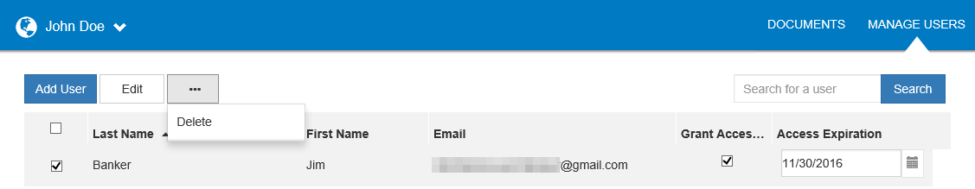
Edit or Delete a Portal User

Access to a Portal may be modified or terminated at any time. In the Manage Users window, click the box to left of the user’s name, and then click the More Options (ellipsis) button to delete the user, or click the Edit button to modify.

It is important to terminate access when no longer needed by the Portal User. If you need assistance please contact [firm name].

